Academic year 2024/2 5 Admission Limits
Picknalls First School published admission number (PAN) is 60.
To comply with class size legislation there will be a maximum of 30 children in KS1 Classes.
The normal point of entry for admission to Picknalls First School is Reception where upon full time places will be available in September of the academic year in which the child becomes five years old.

Catchment Area
The catchment area of the school can be found in appendix 1.

Admissions Criteria
If the number of applications for admission to the school exceeds the Published Admission Number (PAN), the following order of priority is used to allocate the available places. In accordance with legislation, children who have a statutory statement of special educational need, or Education, Health and Care Plan that names the school must be admitted. This will reduce the number of places available to other applications - paragraph 1.6 of the School admissions code 2021.

- A 'looked after child' or a child who was previously looked after but immediately after being looked after became subject to an adoption, child arrangements, or special guardianship order including those who appear [to the admission authority] to have been in state care outside of England and ceased to be in state care as a result of being adopted. A looked after child is a child who is (a) in the care of a local authority, or (b) being provided with accommodation by a local authority in the exercise of their social services functions (see the definition in Section 22(1) of the Children Act 1989).

- Children who satisfy both of the following tests:

Test 1: the child is distinguished from the great majority of other applicants either on their own medical grounds or by other exceptional circumstances.
Medical grounds must be supported by a medical report (obtained by the applicant and provided at the point of application). This report must clearly justify, for health reasons only, why it is better for the child’s health to attend the school rather than any other school.
Exceptional circumstances must relate to the choice of school and the individual child, i.e. the circumstances of the child, not the economic or social circumstances of the parent/carer. They should be supported by a professional report (obtained by the applicant and provided at the point of application), e.g. social worker. This report must clearly justify why it is better for the child to attend the school rather than any other school. And;
Test 2: the child would suffer hardship if they were unable to attend the school. Hardship means severe suffering of any kind, not merely difficulty or inconvenience, which is likely to be experienced as a result of the child attending a different school. Applicants must provide detailed information about both the type and severity of any likely hardship at the time of application.

- Pupils, who at the time of the admission, have an older sibling in attendance at the school.
(For admission purposes a sibling is a child who lives at the same address and who is brother/sister, half-brother/sister (children who share one common parent), step brother/sister where two children are related by marriage. This definition also includes adopted or fostered children living at the same address).

- Pupils resident in the catchment area of the school (see appendix 1)

- Other children arranged in order of priority according to how near their home addresses are to the main gate of the school, determined by a straight-line measurement as calculated by the Local Authority’s Geographical Information System.

Where it is not possible to accommodate all children applying for places within a particular category then the Trust board will allocate the available places in accordance with the remaining criteria. If for instance, all the catchment area children cannot be accommodated at a school, children who are resident within the catchment area will be arranged in order of priority according to the remaining criteria.

Additional notes
Looked after children means children who are looked after by a local authority in accordance with section 22 (1) of the Children Act 1989 and who is (a) in care of a local authority, or (b) being provided with accommodation by a Local Authority in the exercise of their social services functions (see definition in Section 22 (1) of the Children Act 1989) at the time of making an application to a school. This includes children who were adopted under the Adoption Act 1976 (see section 12 adoption orders) and children who were adopted under Adoption and Children Act 2002 (see section 46 adoption orders).

Child arrangements orders are defined in s.8 of the Children Act 1989, as amended by s.12 of the Children and Families Act 2014. Child arrangements orders replace residence orders and any residence order in force prior to 22 April 2014 is deemed to be a child arrangements order.

Section 14A of the Children Act 1989 defines a special guardianship order as an order appointing one or more individuals to be a child’s special guardian (or special guardians).

It is the applicant’s responsibility to provide any supportive information required in order for the application to be assessed against the published admissions criteria, the school will not seek to obtain this information on behalf of the applicant.

The school uses the local authority’s geographical information system (GIS) to calculate home to school distances in miles. The measurement is calculated using Ordnance Survey (OS) data from an applicant's home address to the main front gate of the school. The coordinates of an applicant's home address are determined and provided by the Local Land and Property Gazetteer (LLPG) and OS address point data.

The requirement for the school to meet the infant class size legislation may result in the refusal of catchment area or sibling applications where a class has already reached its limit of 30 pupils. However, as an exception, the school will give careful consideration to offering places above the published admission number to applications from children whose twin or sibling from a multiple birth is admitted even when there are no other vacant places.

The home address is considered to be the child’s along with their parent/carer’s main and genuine principal place of residence at the time of the allocation of places i.e. where they are normally and regularly living. If a child is resident with friends or relatives (for reasons other than legal guardianship) the friends or relatives address will not be considered for allocation purposes.

Where parents have shared responsibility for a child, and the child lives with both parents for part of the school week, parents will be required to provide documentary evidence to support the address they wish to be considered for allocation purposes.

It is expected that parents will agree on school places before an application is made, and it may be necessary to request evidence from you to confirm that this is the case. The school is not in a position to intervene in disputes between parents over school applications and will request that these are resolved privately.

If a child’s home address changes during the admissions process it is the responsibility of the parent/carer to inform the local authority immediately. Where there is a proposed house move taking place during the admissions process the school will only accept the revised address for purposes of allocation where parents/carers can provide documentary evidence of the move by 12th March 2025. It will be necessary for sufficient evidence of a permanent move to be provided by the applicant by this date before it will be taken into account for allocation purposes at the national offer date.

If a place is offered on the basis of an address that is subsequently found to be different from the child’s normal and permanent home address at the time of allocation of places then that place is likely to be withdrawn.

If there are a limited number of spaces available and we cannot distinguish between applicants using the criteria listed, such as in the case of children who live in the same block of flats, then the child or children who will be offered the available spaces will be randomly selected. This process will be independently verified.

Waiting lists
Unsuccessful applicants will be placed on a waiting list in accordance with the oversubscription criteria stated above and not based on the date their application was received. There will be a period of two weeks after the national offer date whereby available places will not be reallocated. If places become available after this date they will be offered according to the child at the top of the waiting list.

The waiting list will operate until the cohort concerned leaves year 2 and parents will be written to each year to ask whether they wish their child’s details to remain on the list.

Inclusion on the school’s waiting list does not mean that a place will eventually become available at the preferred school.

A child’s position on a waiting list is not fixed and is subject to change during the year i.e. they can go up or down the list since each added child will require the list to be ranked again in line with the oversubscription criteria.

Children who are subject of a direction by a local authority to admit or who are allocated to a school in accordance with the fair access protocol will take precedence over those on the waiting list.

Late applications
Preferences received after the closing date will be considered alongside those applicants who applied on time wherever possible. Where it is not practicable because places have already been allocated, or are shortly to be allocated, then late preferences will be considered only after those that were made before this point.
A late application does not affect the right of appeal or the right to be placed on a school’s waiting list.

Admissions Procedure - Reception

Applications for reception can be made online at Staffordshire school admissions:

https://www.staffordshire.gov.uk/Education/Admissions-primary/Apply/Overview.aspx

Alternatively, a paper application can be obtained from the school office or downloaded from and returned to Staffordshire School Admissions.

Parents will receive the outcome of their application on National Offer Day. Early in the Summer term a letter will be sent by the LA offering a place at the school, or stating that no place is available.

“In-year admission” arrangements
Parents or carers seeking to be admitted Picknalls First School may make an application using the appropriate application form. This application will be processed in line with the procedure outlined in the determined admission arrangements and parents and carers need to be aware that in the case of transfers between local schools, any date set for joining the new school may be after the next term or half term holiday and those parents/carers are responsible for ensuring that their child continues to receive appropriate education in the interim. Authority to admit is delegated to the Headteacher, providing a place is available.

Appeals
Any parent has a right to lodge a formal appeal if their child has been refused a place at Picknalls First School. Appeals can be submitted to:

Admission Appeals - Staffordshire County Council - https://www.staffordshire.gov.uk/Education/Admissionappeals/home.aspx

The decision of the appeals panel is final and binding on all parties.

Deferred Entry to Reception Class
Parents may request that their child be admitted to Reception Class on a part-time basis, or that their child be admitted to school later in the same academic year until the child reaches compulsory school age (i.e. beginning of the term after the child’s fifth birthday). The effect is that the place will be held for the child in Reception and is not available to be offered to any other child within the same academic year in which it has been offered.

Before deciding whether to defer their child’s entry to school, parents should visit the school to clarify how we cater for the youngest children in Reception and how the needs of these children are met as they move up through the school.

Admission Outside of the Normal Age Group
Parents may seek to apply for their child’s admission to school outside of their normal age group, for example if the child is exceptionally gifted and talented or has experienced problems such as ill health. In addition, the parents of summer born children may choose not to send their child to school until the September following their fifth birthday and may request that they are admitted outside of their normal age group to Reception rather than Year 1.
These parents will need to make an application alongside children applying at the normal age which should explain why it is in the child’s best interest to be admitted outside of their normal age which may include information such as professional evidence as to why this is the case and why an exception should be made in the case of the child. A decision as to whether this is an appropriate course of action will be made by the Local Governing Board who will consider the circumstances of the case and views of the headteacher. Parents do not have the right to insist that their child is admitted to a particular year group.

Approved on behalf of the Local Governing Board:

Signed:

Date:

PICKNALLS FIRST SCHOOL ADMISSIONS ARRANGEMENTS 2024/25 Appendix 1 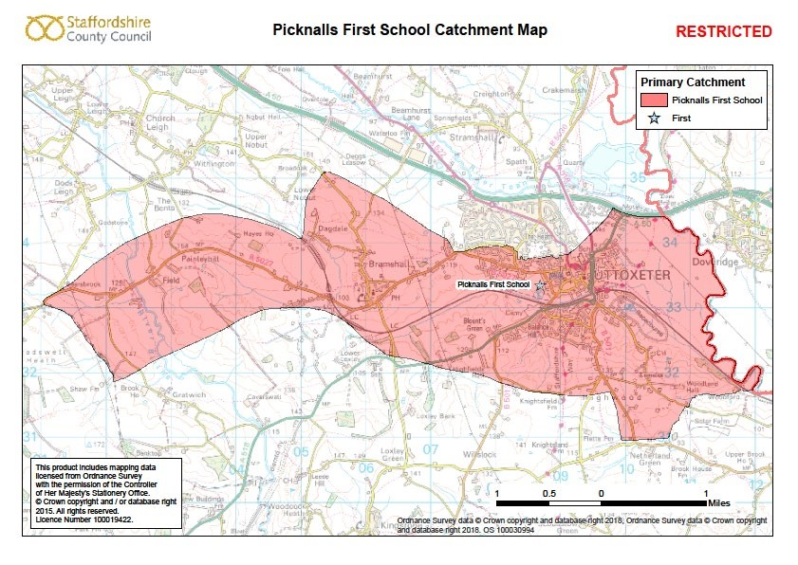

Picknalls First School Admissions Arrangements for Academic Year 2024-25 ULT

